***Collezione Cinquanta***

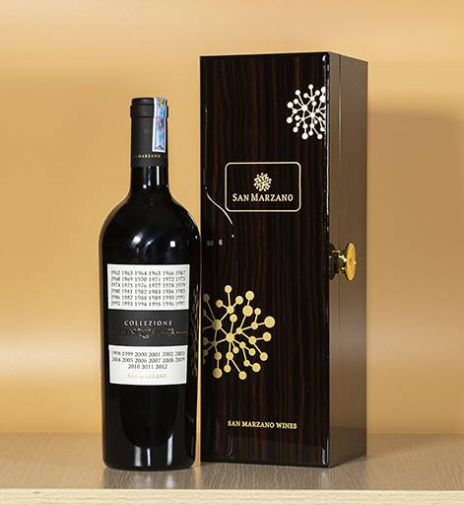

*This bottle of wine is a typical product of the Italian wine brand Cantine San Marzano. They were born as bringing a very personal style so that anyone who looks at the bottle will become impressed from the very first moment. It's a beautiful deep purple ruby ​​red color that attracts the eye. In addition, it is its taste that is the basic factor to conquer the hearts of wine users. The wine has strong aromas of many ripe fruits such as ripe plums, assorted fruits and vanilla. A slight note of aroma from licorice also adds richness to the wine. With such a gentle and romantic wine, there is no reason for wine users to refuse to own a bottle of wine. Possessing a perfect wine quality at a very affordable price, not too expensive….wine is always a great choice for customers."*